**Weight bridge process:**

T-Code: ZWB1

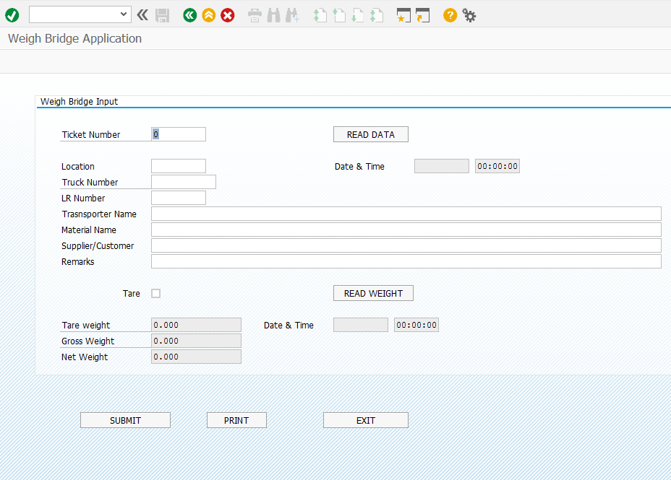

Input data as per below: 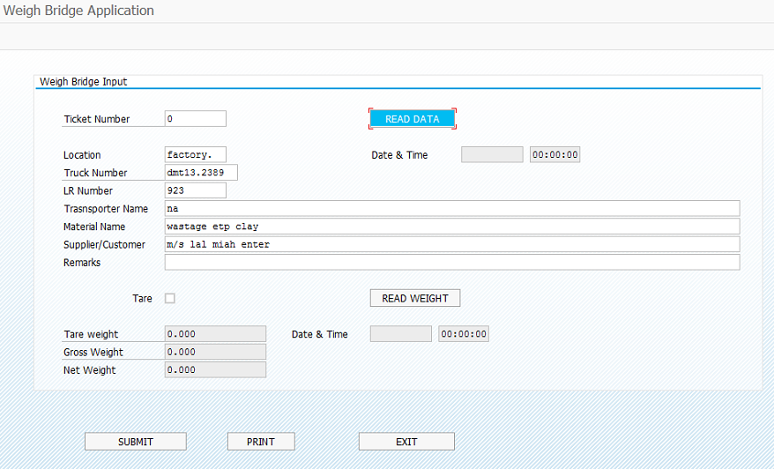

Now click on “READ DATA” and then check mark on “Tare” and click “READ WEIGHT”

**Note:** If the truck is empty then only check mark on “Tare”.

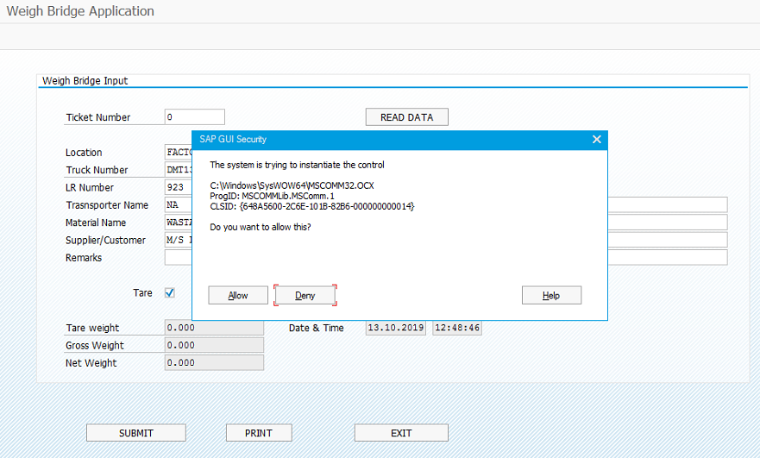

Now click on Allow.

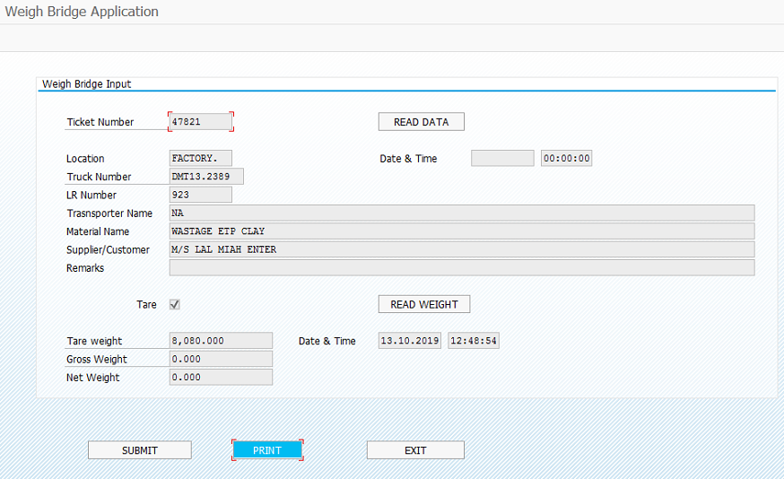

Now click on “PRINT”

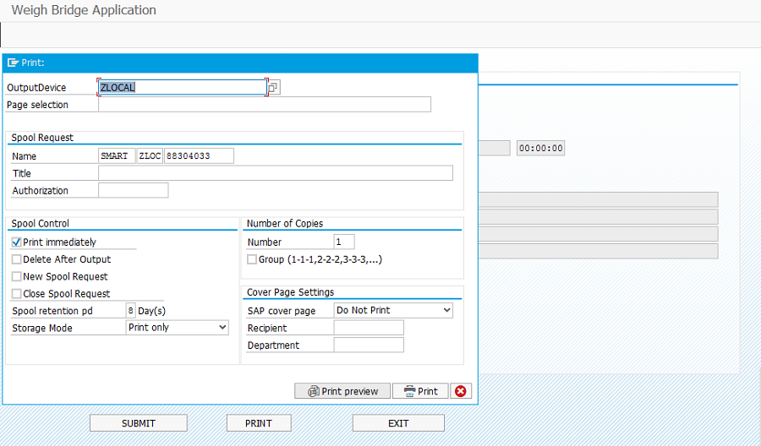

Then go to the “Print preview”

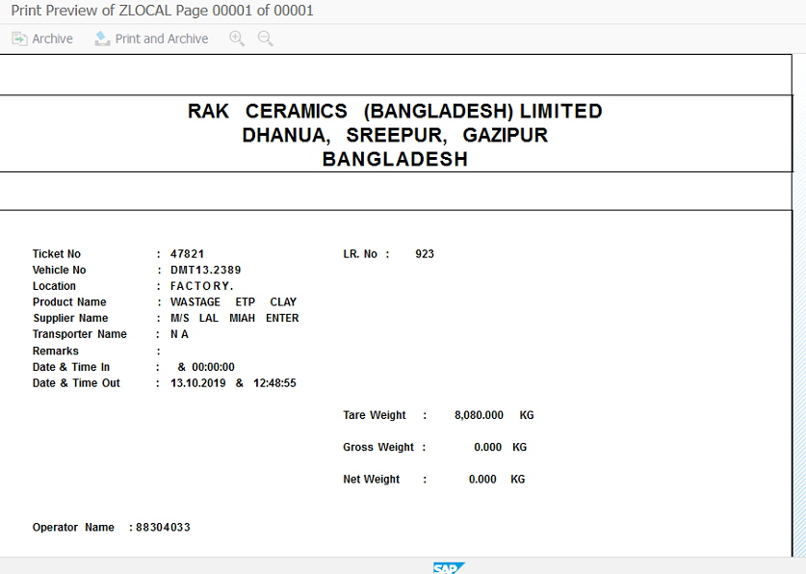

This is first weight print preview and operator note down the Ticket number on Challan copy.

2nd Weight:

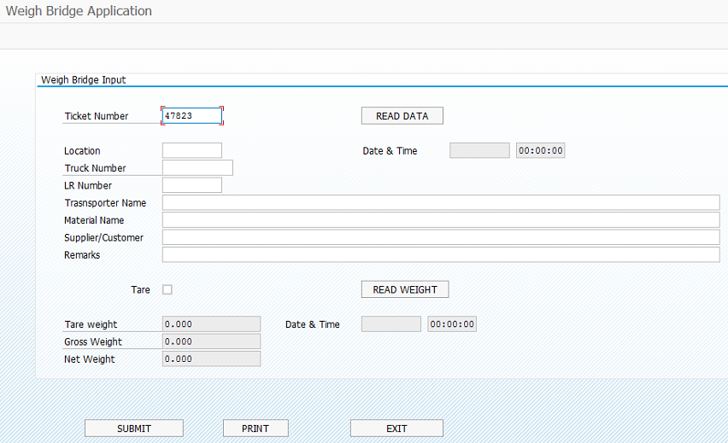

Manually entering the ticket number

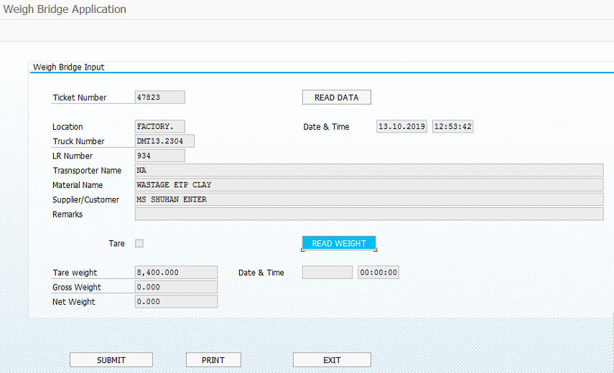

Now click on “READ WEIGHT”

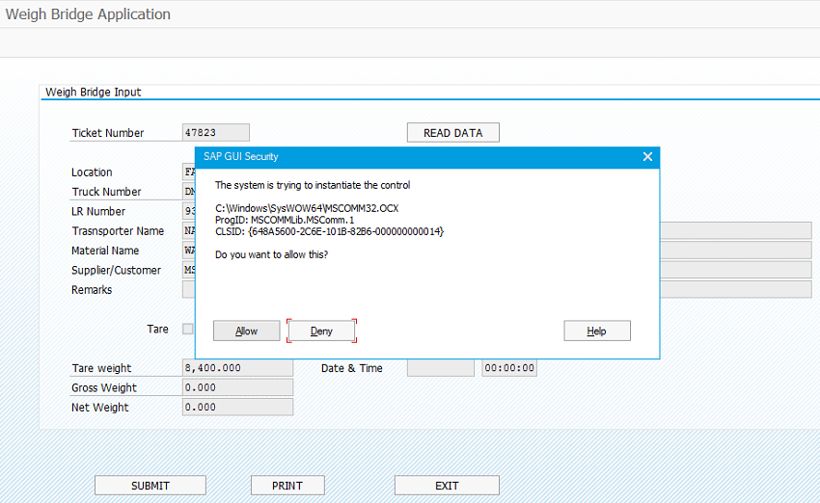

Now click on “Allow”

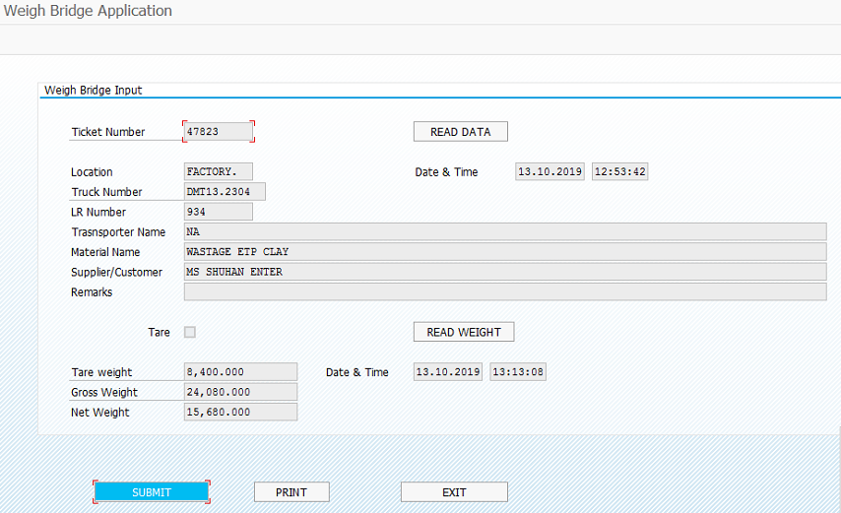

Now click on “SUBMIT”

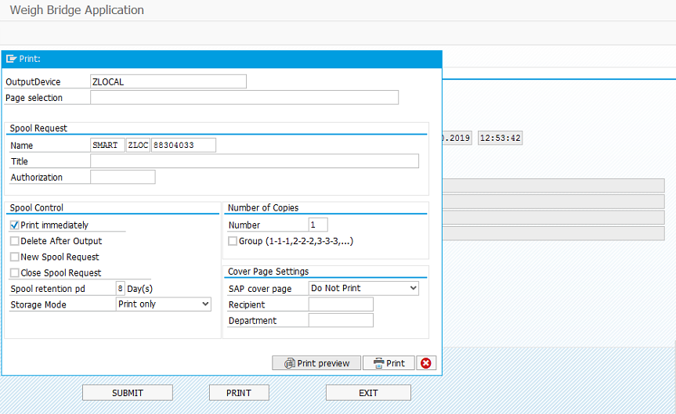

Now go the “Print preview”

Final Print:

